Providing liquidity reduces volatility + obv more accurate prices

Reservation pirce =minimum spread for which the market maker can make a profit

The options are less volatile then the underlying (Like imgine all the strikes right)

**Managing inventory is important for risk management**

In the money means that by excercising the option you make money (ez as that)

Out the money is the flip side

At the money is if the strike = asset price (at excercising)

Like when excercising for American is ongoing innit

OPTION VALUE = intrinsic + extrinsic

**We use the BSM to calculate the fair value of the option**

**OR you calculate the expected value (like think what are the future possibilities and their probabilities – you can visualise this as a Binomial distribution (basically plots the value=outcome and probability)**

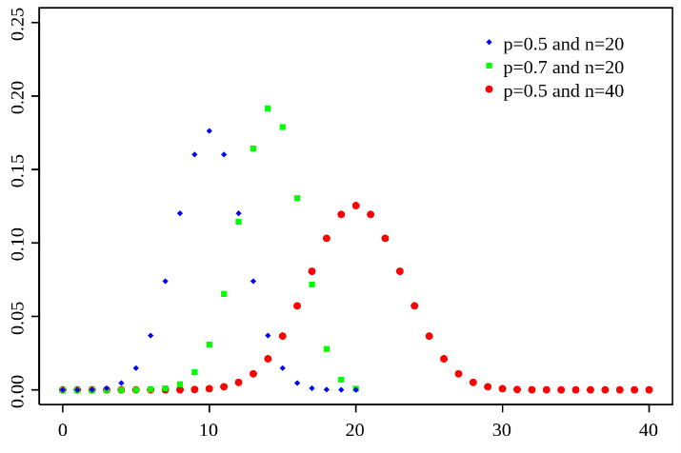

**Here, n is observations, so nr. Of outcomes, and p is the success rate (probability the outcome will happen).**

**This is for the underlying ok so these prob and outcomes are for the underlying. And that probability is called VOLATILITY.**

**THESE SMART PPL Black-Scholes ASSUME THAT: FUTURES PRICE CHANGES FOLLOW A LOG-NORMAL CURVE/DISTRIBUTION -> the volatility/probability of an outcome/change is given by the log-normal curve/distribution**

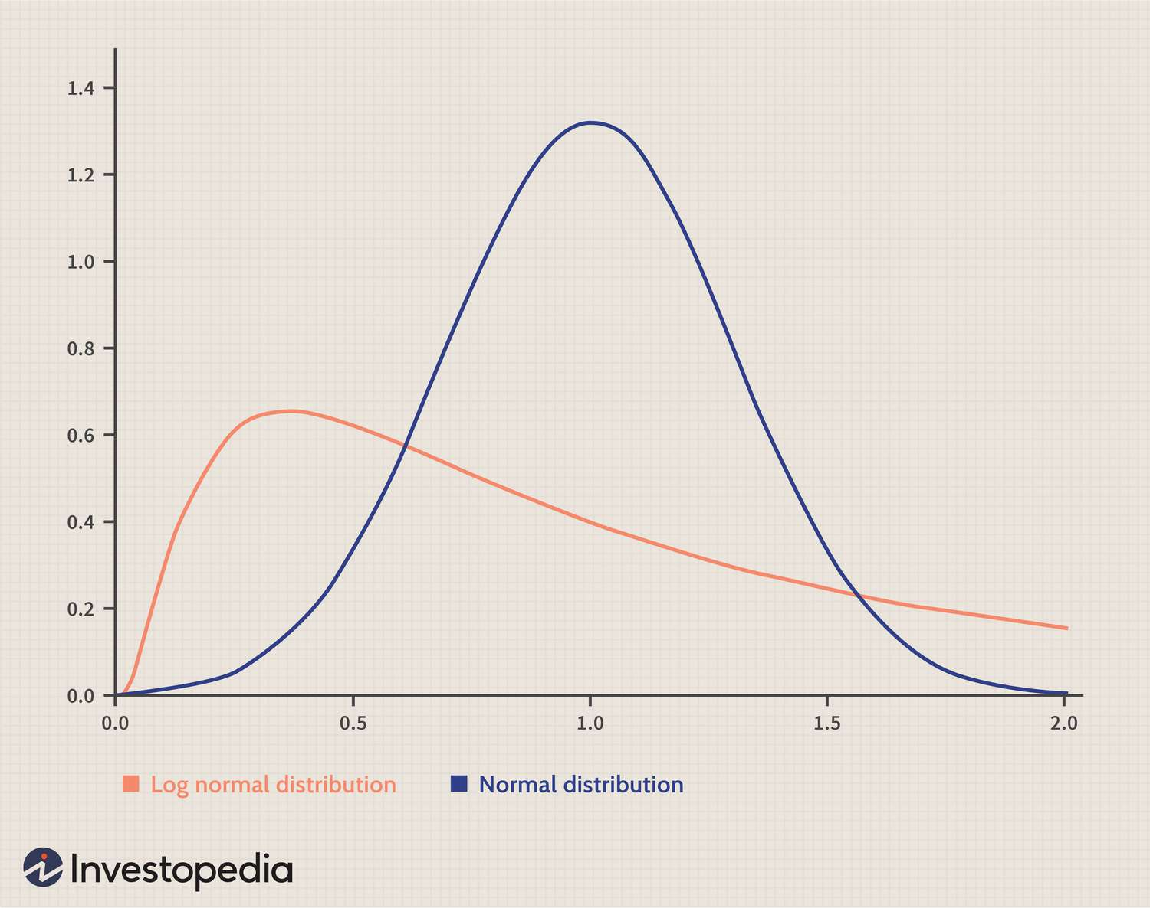

**Put-Call-Parity (to see the BSM evolution):**

$$C-P=S_{0}-Ke^{-rt}$$

**The BSM is for European options:**

$$C=S_{0}N\left(d_{1}\right)-Ke^{-rt}N(d_{2})$$

$$P=Ke^{-rt}N(-d_{2}){ - S}_{0}N\left(-d_{1}\right)$$

$$d_{1}= \frac{ln\left(\frac{S_{0}}{K}\right)+\left(r+\frac{σ^{2}}{2}\right)t}{σ√t}$$

$$d_{2}=d_{1}- σ√t$$

**Explanations:**

As you can tell, C and P are expected values.

$$C=call theo$$

$$P=put theo$$

$$K=strike$$

$$S_{0}=current price of oil future$$

$N_{(d)}= the probability that a variable following the standard normal distribution (0,1) is ≤ d$, d $∈$ [- $∞$, + $∞$] but in practice, d $∈$ [- $3$, + $3$]

$$t=years to expiration$$

$$r=interest rate over the option^{'}s life$$

$$e^{-rt}=smart discounting$$

$σ=implied volatility of the oil future price$ = SD (standard deviation) of price around the mean over a 1-year period [this is for logic ONLY] / IN REALITY $σ=SDV$

$$SD= \sqrt{\frac{\sum{({P-P^{bar})}^{2}}}{N}}$$

$$SDV= \sqrt{\frac{\sum_{i=1}^{N}{({\ln{(\frac{P_{i}}{P_{i-1}})}-\frac{1}{N}\sum_{j=1}^{N}{\ln{(\frac{P_{j}}{P_{j-1}}}}))}^{2}}}{N-1}}$$

$$HV\left(HISTORICAL VOLATILITY\right)=SDV$$

**Now, why SDV:**

1. **Normal Distribution Assumption**: Log returns (SDV) better fit the normal distribution, which is crucial for many financial models.

2. **Compounding Effects**: Log returns naturally account for compounding, making long-term return calculations simpler and more accurate.

3. **Symmetry**: Log returns are symmetric around the mean, simplifying statistical analysis.

4. **Stability**: Log returns are less sensitive to outliers, providing a more stable measure of volatility.

**Mindset**

Market makers are not so much interested in what real or true fair value may be as in which options are mispriced relative to each other under the same model.

Volatility is the only tricky input parameter. See, volatility in the BSM is the future volatility not the historic one. So, it’s the volatility measured from now to expiration. But you don’t know how the price of the oil future will fluctuate from now to expiration.

There are 3 kinds of volatility. The historical one (HV) that is ez to calculate with 100% accuracy. The future volatility, which, frankly, no one has any clue what it will be. And the implied volatility which is calculated from the current price of an option by working out the BSM for $σ$.

Ok so market makers use the implied volatility (like most current value) to set the bid and ask (like they will use a value around that implied volatility) and use historical volatility for reference.

**Finanical and futures options chapter**

For oil there is a negative cost of carry due to storage cost, insurance cost, shipment cost etc. which raise the forward price.

**GREEKS**

**VERY IMPORTANT: WHEN I SAY OPTION THAT MEANS YOU GOTTA TREAT THE FORMULA FROM THE PERSPECTIVE OF THE *CALL & PUT*. GOTTA PUT SOME THOUGHT INTO IT. PLUS I ALSO ASSUME LONG VIEW OF BOTH CALL AND PUT IN WHAT I SAY BUT I REALISE YOU CAN HAVE THE SHORT VIEW.**

**Delta**

$$Δ (A.K.A. HEDGE RATIO)= \frac{Change in option price}{Change in oil future price}$$

It's much easier to understand the concept if you are thinking about European options.

I'll also say that delta is a good proxy for the probability of an option finishing in the money or out the money at expiration, but it's not a probability alright.

This is for a portfolio’s delta:

You can also think that this is the exact same way in which you try to maintain a delta of 0, which is market neutral.

Some ideas say that if the option is well in the money, then the change in the option will mimic the change in the future, so delta = 1. Now, if the option is well out of the money, then delta = 0, and if the option is at the money, then delta = 0.5. So, a delta between 0.5 - 1 suggests the option EXPIRES in the money. Between 0 - 0.5, the option is expected to EXPIRE out the money. What I said applies for call options where delta is between 0-1.

For put option delat is between -1 – 0. Right so if delta is -1 it means that for a $1.00 decrease in the oil future the price of the put increases by $1 this happens when you are already well in the money.

Now the flip side of this is if you are already well out the money, then a $1.00 decrease in the future won't impact the price of the put, so $0 change in the put price just because it's highly unlikely that the put will be worth anything at expiration.

**Mindset behind delta + explained gamma as an aside**

So it's it's pretty much what are the chances that given the option is well out the money, it will it will eventually be or be worth something. But what I would say is like think of it as a function of time and distance from the strike. So for example if you are very close to the expiration date and you're put is well out the money meaning that the price of the of the underlying which is the future is very high yeah so the price will not the price of the option won't be changed by March if the future FDA sorry if the underlying all decreases by $1.00 OK. So now assume the same situation but you are further away from the expiration date meaning you have more time for things to happen to the future price so as to get the option in the in the money interval now if the price decreases right like the price is already higher than the strike if the price decreases by a dollar the delta will be more than zero OK so it will be more sensitive to the change in the underlying just because you have more time till exploded the expiration date so basically there is a higher probability that you can eventually end up in the money. So again, think of delta as a function of how far away you are from the strike and how much time you have till expiry. And that basically dictates the sensitivity of the change in the option price given a $1.00 change in the underlying. And I think that's going to be gamma but whatever.

Besides you have to think of The change in volatility implied volatility of the underlying so for example if you are well in the money OK think of a call option if and obviously you already have a volatility attached to it OK you know you have a volatility attached to it you have a delta attached to it, now if the implied volatility increases there is a higher probability that the option will move to out the money. Why? Well, let’s only think about the worst cases when the underlying price goes against your desire, thus bringing an undesired change to the option price. This is because we don’t care if you move further in the money since the delta will still be 1, like after a certain threshold, the delta is 1 no matter how far off you go in the money which means you really only care about the cases in which the underlying price moves agains you. As mentioned, you are well in the money, so if the volatility of the underlying was low, this means that the price changes were small, so the underlying price doesn’t deviate by much. Then the option’s price can’t deviate by much so it’s less likely to transition to out the money cause the change is limited. But if volatility is high then the underlying price changes can be high, so the option price changes can be high so it’s mor elikely that you can end up out the money. Hope you got the thinking.

So maybe think of delta as a ratio that you use to hedge your positions But given the fact that you need this delta at all times you need to know how sensitive it is to a change in the underlying and I told you that **delta’s sensitivity is given by the how much time you have till expiry + how well in the money or out the money you are + implied volatility of the underlying. Plus you have to consider the change in the underlying (the obvious one). This sensitivity is called gamma.**

$$Gamma=\frac{Net change in ∆}{Change in the oil future}$$

So if a call has a delta of 0.3 and the underlying experiences a positive increase of 1 dollar, which leads to the delta being 0.35, the gamma is 0.05. So, the change in delta with a change in the underlying (that’s gamma).

**Then you have lambda (which is not wow):**

$$Lambda=\frac{\%change in option value}{\%change in asset price}$$

In my mind this says how much will my option price change by if the underlying changes by 1%. Pretty much similar concept to delata but here I can tell the magnitude of the change whereas in delta you play with numbers. Kinda like same analogy as with stocks like wow my stock went up by 1$, right but what was the % increase in your wealth cause if you bought the share for 1$ you made 100% retuns but if you bought it for $100 you made 1% return. Let’s u quantify the actual change in a way you’ll understand what’s going on.

So important, I’d say so. Like, I think I would use lambda more than delta tbf.

And lambda is mainly > 1 because options, by definition, I guess, or in general, are leveraged instruments relative to the underlying. They give you access to returns that would require you to pay loads in the underlying market, say (1000 barrels), for much less. It's about the multiplier. That is what it is about. Cuse with $500 say you buy a call option on 1000 barrels and get exposure to the returns of 1000 barrels. Whereas without the call, you had to buy the 1000 barrels for, let’s say, $1.2 M. Ok, that is some of the crooks of options in general.

Lambda is 1 if you are well in the money cause for the same reason as delta is 1. You treat the instrument as if it were the underlying.

**Theta (more interesting)**

Theta risk = time decay

$$Theta=\frac{Change in option value due solely to the decay of time}{1(day)}$$

So, in practice you should have days like you can look for the change over a timeframe of days but theta will still be the average option price change across the days. Now when I say change I mean the change that is SOLELY due to the passing of time. So you MUST ISOLATE THE EFFECT OF TIME PASSING ON THE OPTION PRICE.

So it is thought that holding ceteris paribus, if u have more days the contract is woth more cause of greater flexibility. So if you bought a contract each day u lose some value cause the flexibility goes so the person buyin it off of you will give you less. For shorting an option is the reverse, I make money cause the option is less valuable by the day.

**Vega**

Apparently the most important risk

$$Vega=\frac{Change in option price}{Positive 1-point implied volatility change}$$

**So just to know vega is vol risk, theta is time risk, delta/lambda/gamma are price risks**

Literally like you know the implied vol and price of a call option say. Next thing u know the price changed because of the change in vol. Say the change in price was an increase of $0.33 and the change in vol was an increase of 1 point so from 15 to 16 (positive). Then the vega is 0.33. Now you can also experience price decreases so you could have have a decrease of $0.33 the vega would have been -0.33.

And u know there is lingo so if I say I am long volatility this means I have a positive vega position (aka I make money if vega goes up) like u can lose money if vega goes up so the reason for the lingo.

**RHO**

Cost of carry risk (includes interest rate and insurance and shipping and storage fro oil)

$$Rho=\frac{Change in option price}{Change in carry cost}$$

So if carry cost goes up the future goes up and so the call option is closer to in the money given the same strike so the call option is worth more.

Or by BSM the call goes up cause the future goes up and the PV(K) goes down.

On the flip side, if the carry cost goes down the call goes down in value.

And the above happen if you are long the call. Now I added the comment at the very begingin of Greek.